
Member Committee (MPC) Meeting – February 25, 2026
Minutes captured by Chelsea Loomis

Agenda
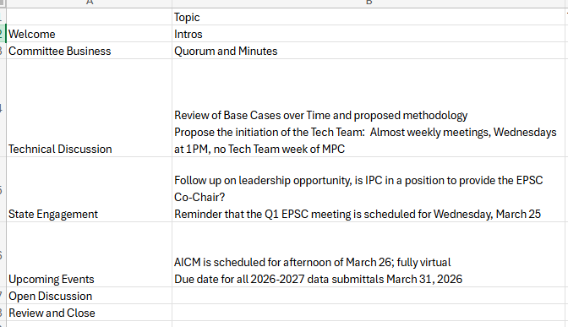

Committee Business
Quorum was established. January 2026 MPC Minutes were passed upon motion to approve provided by J. Young, BPA and second provided by Z. Zornes, CHPD.

Technical Discussion
A reminder that all data submittals are due March 31, 2026 for the 2026-2027 NG Planning Cycle. The team decided that a Technical Team doesn’t need to be formed until after the data submittal.

State Engagement
IPC confirmed that Stephen L. will serve as EPSC co-chair for the 2026-2027 NorthernGrid planning cycle.

Upcoming Events
AICM is scheduled for Thursday, March 26. The quarterly EPSC will meet on Wednesday, March 25.

Open Discussion

Review and Close

Attendance
