Members Planning Committee (MPC) Meeting – June 15, 2022
Minutes captured by Scott Beyer, WPP

Introductions
Quorum established – 11 parties represented. Chelsea kicked off the meeting and ran through the May meeting minutes. Motion to approve by Kishore Patel, seconded by April Spacek. May meeting minutes approved by consensus.

SharePoint Review
Chelsea provided a quick refresher walkthrough of the NorthernGrid SharePoint and where to find documents, and specifically the Study Scope:
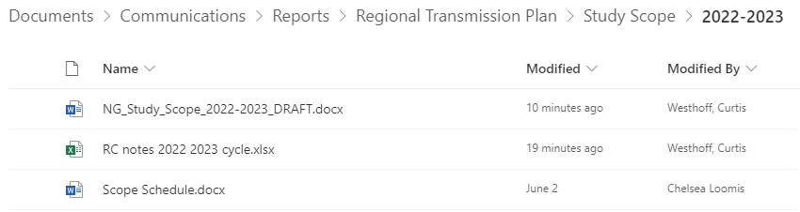
All members can access the documents in the SharePoint at any time and should actively use the site to review and collaborate on all documents, maps, reports, etc. being developed to support the NorthernGrid Regional Transmission Plan. Edits and revisions can be made directly in editable documents (Word, Excel). If there are updates need to non-editable documents, revisions and comments can be sent by emails to Chelsea and Scott.

Summary Slide
A summary graphic is being developed based on what was included in the RTP last cycle, but with the addition of the expanded NorthernGrid footprint and slightly adjusting the data given in the graphic for each member Balancing Authority Area and the combined NorthernGrid footprint as follows:
- Average Annualized Growth
- Number of submitted regional transmission projects
- MW of proposed generation additions
- MW of proposed generation retirements
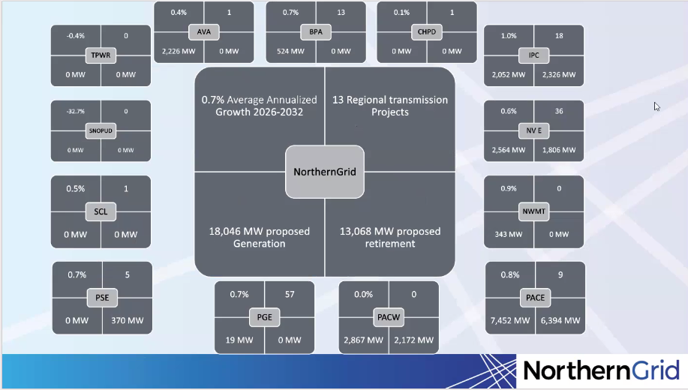
The data used to generate the graphic was developed from the member L&R submittals and combined into the 2022-2023 NG Summary-treatasconfidential.xlsx spreadsheet:
2022-2023 NG Summary-treatasconfidential.xlsx
Curtis Westhoff noted that the Idaho Power generation totals included existing resources. These resources are shown in the generation additions tab but with commissioning dates prior to 2022. Chelsea will review and ensure those existing resources are not included in the summary graphic as new generation additions.

Study Scope Review
Study Scope Development Team (SSDT) has substantively completed development of the Regional Transmission Plan Study Scope. The Study Scope document is being drafted for stakeholder review. A read-through of the draft document was conducted. This cycle includes 141 local transmission upgrade projects, 13 regional projects and 4 non-incumbent projects.
Four base case conditions were identified by the SSDT for evaluation in the RTP study:
Summer Peak/High COI/PDCI southbound flows, high NW-ID flows
Winter Peak (propose average position for resource dispatch)
California high S->N export case
High Wyoming Wind export (night)
Additional graphics are currently being developed to support finalizing the document for stakeholder review. The Regional Transmission Plan study will evaluate the baseline no projects case and the baseline member projects case. Then each regional project will be tested by itself, in addition to the various combinations of regional projects developed by the SSDT.
Chelsea also walked through the Regional Combinations table that was developed by the SSDT to determine which project combinations will be evaluated against each of the base case conditions.

Posting of Study Scope for Stakeholders
Target approving scope in July 20 MPC meeting, requires sharing the draft Study Scope with stakeholders today to allow for 15 day comment period.

Open Discussion
None

Decisions:
None

Actions:
Action Item: Chelsea to update Idaho Power and Avista generation totals to properly account for generators already in-service (commissioning dates prior to 2022). Updates will be incorporated throughout Study Scope document and summary graphic.

Representatives:
NorthernGrid Member Attendance
Member | Representative | Y | Alternate | Y | Count
Avista | John Gross | 0 | April Spacek | 1 | 1
BPA | Berhanu Tesema | 1 | Paul Nguyen | 1 | 1
Chelan | Zach Zornes | 0 | Steve Wickel | 0
MATL | Sharmen Andrew | 0 | Ani Chopra | 1 | 1
IPC | Curtis Westhoff | 1 | Stephen Longmuir | 1 | 1
NV Energy | Alex Ford | 0 | Charles Pottey | 1 | 1
NorthWestern | Matt Stajcar | 1 | Kim McClafferty | 0 | 1
PAC | Rikin Shah | 1 | Kishore Patel | 1 | 1
PGE | Ian Beil | 1 | Chris Kulink | 0 | 1
PSE | Erik Olson | 1 | Emily Hnatishin | 0 | 1
SCL | Desmond Chan | 0 | Rob Jones | 0
Sno PUD | Ken Che | 1 | John Martinsen | 1 | 1
Tacoma | Khanh Thai | 0 | Megan Cammarano | 0
EPSC Enrolled Party Chair | Graham Retzlaff | 1 |  | 0 | 1
EPSC State Chair |  | 0 |  | 0
 |  |  | Quorum | Y | 11

